Assignment 1 Hello Date

# Learning Objectives:

1. Write an Android app that displays a single button that takes up the **whole** screen
2. Your app should display the current date when the app **first appears and again each time the button is clicked.** The start screen should display the date when the app is started. (Feel free to design your own UI design as long as the app meets the requirement.) Note that the button occupies the whole screen. Since your app date should display the current date and time, your hello date display will be different from the below screenshot.

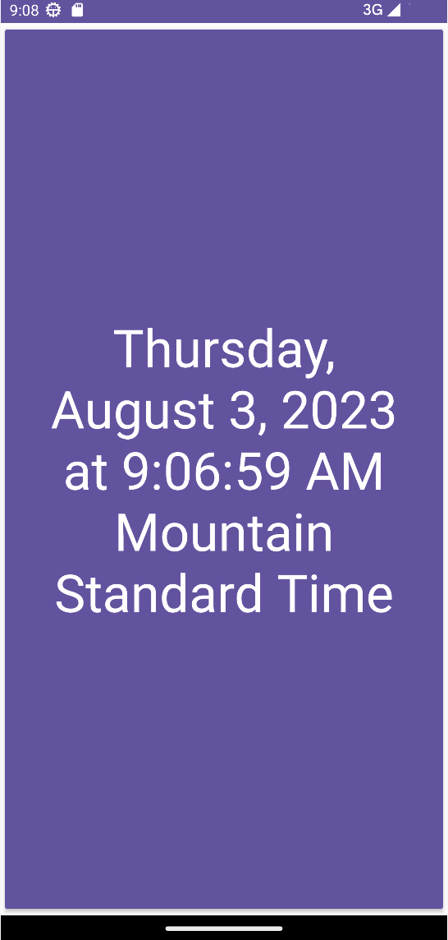

1. Write the app such that it responds to a user event (a button click) and the display **changes** each time.

# Requirements:

Use Android Studio to develop this app. Android Studio will create a default ***AndroidManifest.xml*** file, a default activity MainActivity.kt file, as well as a default layout .xml file (along with other files and directories for your project). The layout .xml and the activity .kt file will need modification.

You will run this app on an AVD you created when setting up your Android Studio, not on an actual mobile device.

# Notes:

1. When you use Android Studio to create the project, choose Empty Views Activity if you are using the up-to-date Android Studio, name the project something meaningful like "HelloDate".
2. You will need to specify a package name for your java source (and compiled) code. Your java source package is expected to be like below:

**edu.arizona.cast.yourname.hellodate**

You need to provide a domain such as "yourname.cast.arizona.edu" when creating the new project in Android Studio

1. *For "yourname", please use your real name*. Not "your name." [This will be able to facilitate my grading. Thank you!]
2. You will need to slightly modify the layout *.xml* file to include an entry for a Button component.
3. There are several ways to set up an event response code in the Android world. For this assignment, you must implement the *setOnClickListener(View.OnClickListener) of* your Button. You can check the code example (GeoQuiz app) covered this week.
4. You can use the below function when you need to display/update the current date/time. In order to use the below code, you will practice importing the recommended packages in Android Studio.

@RequiresApi(Build.VERSION_CODES.*O*)

**private fun** displayDate() {

**val** dateTime = LocalDateTime.now()

**date_button**.*text* = dateTime.format(DateTimeFormatter.ofLocalizedDateTime(FormatStyle.*FULL*).withZone(

ZoneId.systemDefault()))

}

Note that the code assumes that the button is held by the variable **dateButton** in your activity code. You can declare the variable in your activity class using the below statement:

**private lateinit var date_button: Button**

1. **Note that you need to use an emulator that runs API 26 (Build.VERSION_CODES.*O)* or higher in order to use the above function.**

# Turn-in:

You will turn in your project package (zip it to a zip file). And submit the zip file to the Assignment Dropbox folder **Assignment 1 Hello Date** by the due date announced at the course home page.

In order to package your project into a zip file, with your project opened in Android Studio, you may choose menu **File/Export/Export to Zip file**. A pop-up window will show to ask you where you would like to save the project zip file in your local machine. After you have the zip file saved, you may submit it to the Assignment folder in D2L.

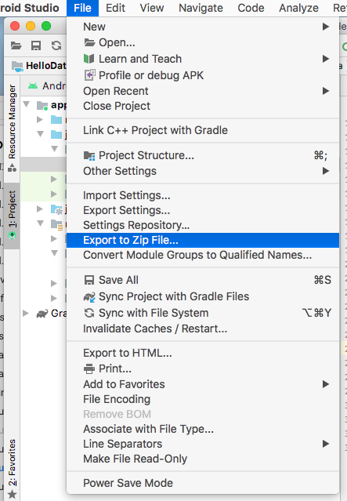

Then, you can go to your local file system, and submit the saved zip file to D2L assignment folder.

Don't forget to format the program nicely. This is a simple program to write. It should not be hard.